Name:______________________________________ Date: ____________ Period: ____
Lesson 2.1.2 Homework Problems 2-26 to 2-30
2-26. Which of the following fractions are repeating decimals and which are terminating? Show how you made your decisions.
a) b) c) d)

2-27. Fill in the missing parts of the portion webs below.
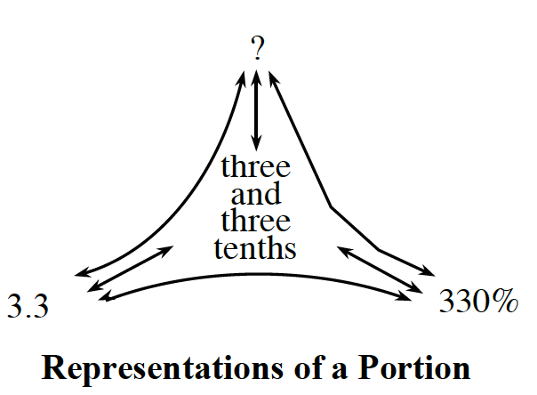
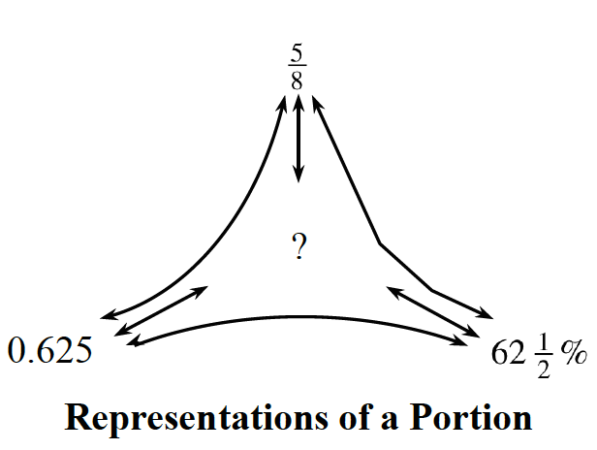
a) b)

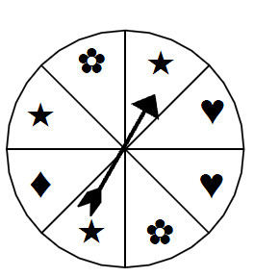
2-28. Lila is making a spinner game for her cousins to play. She has divided it into 8 equal sections and has labeled each section with a symbol. When the spinner lands on a flower (), her cousins will win a prize. Create a spinner to explore your ideas!
a) What is P()? Express your answer as a fraction, as a decimal, and as a percent.

b) What is the probability of not getting ? Write your answer as a fraction, as a decimal, and as a percent.

c) What is P()? Write your answer as a fraction, as a decimal, and as a percent.

d) If Lila's cousins spin 100 times, about how many times would you expect them to spin a heart ()?

2-29. Complete the scale by labeling the remaining tick marks.
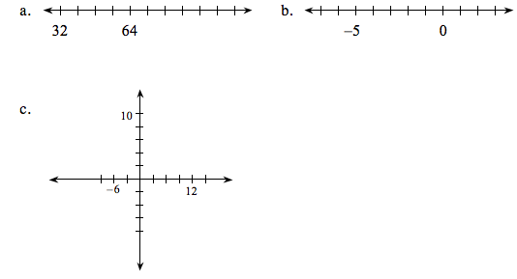
2-30. Approximately 3 out of every 25 Americans live in California. About 3 out of every 50 Americans live in New York, and about 2 out of every 25 Americans live in Texas.
a) Which state has the largest population?

b) Which state has the smallest population?

c) About what percentage of Americans do not live in California, New York, or Texas?

